
SATISH CHANDRA MEMORIAL SCHOOL
HIGH ORDER THINKING SKILL TEST
AUGUST 2024
SUBJECT-MATHEMATICS
STD VII
MM: 16 TIME : 35 MIN
(1) Two poles of heights 9 m and 14 m stand upright on a plane ground. If the distance between their feet is 12 m, find the distance between their tops. 3
(2) A man goes 35 m due West and then 12 m due North. How far is he from the starting point? 2
(3) In the given fig, find: $(i)$ $∠ACD \left(ii\right) ∠ADC \left(iii\right) ∠DAE$ 3
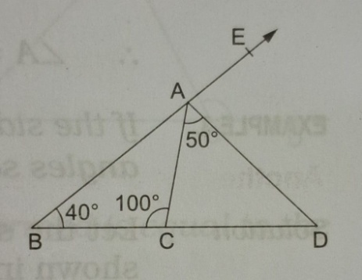
(4) In the adjoining fig, prove that $∠A+∠B+∠C+∠D+∠E+∠F=360°$ 3
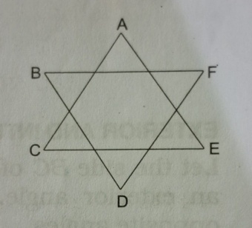
(5) Find the value of the expression $\left(\frac{8}{5}x^{2}-\frac{2}{3}x^{3}+\frac{3}{2}x-1\right) for x=-2$ 3
(6) Can a triangle have (i) two right angles? (ii) two obtuse angles? (Give reason) 2

